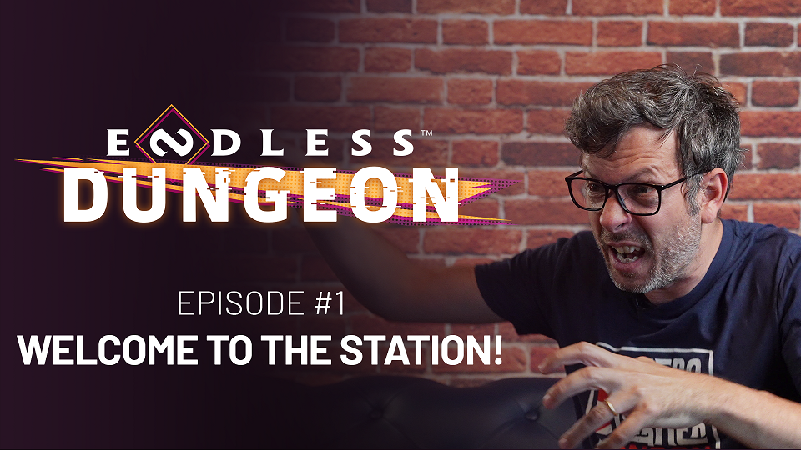

ENDLESS™ DUNGEON FEATURE FOCUS #1

“WELCOME TO THE STATION”

  - Amplitude Studios is launching a video series focused on ENDLESS™ Dungeon.
In Ep. 1, learn about the game’s creation and de-mystify the connection to its predecessor!

Paris, June 17th -- Hot off the tail of our very first gameplay trailer, debuted at the Summer Game Fest kick-off, we’re back with more, spicy ENDLESS™ Dungeon content. This time it’s the first in a series of videos that we’re creating to present our next entry into the rogue-lite genre.
For this first installment, we’re covering the backstory! Like its predecessor Dungeon of the ENDLESS™ (aka DotE), ENDLESS™ Dungeon is a rogue-lite, tower-defense, tactical strategy game with multiplayer co-op. But while DotE was a bit of an accident, it became such a fan favorite that we just had to create its spiritual successor.
Of course, there are many key differences, including twin-stick action and direct control, plus current and next-gen console support from Day 1.
Check out the video to hear straight from the brains behind the games, plus see some brand-new extended gameplay footage!
We hope you enjoy,
- the Ampliteam

